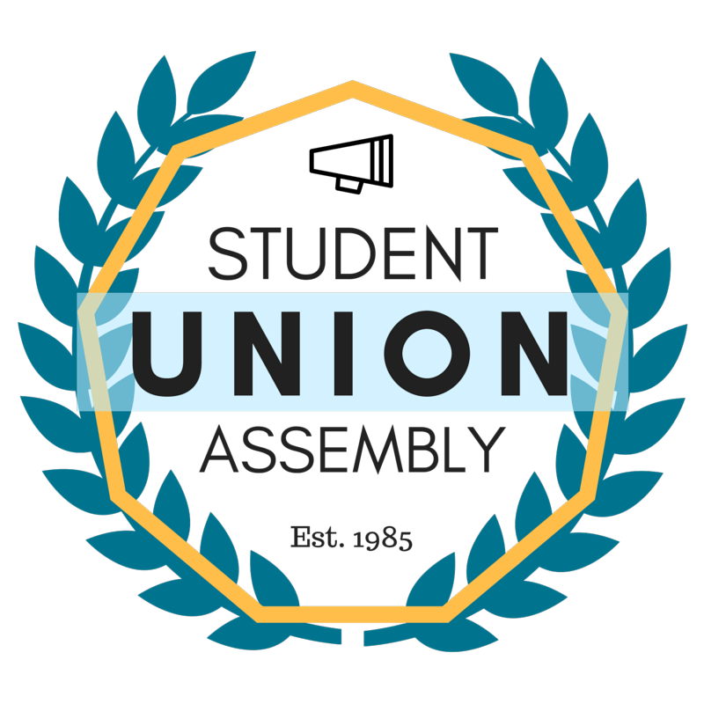
Student Union Assembly
Monthly Report
________________________________________________________________________________
SUA Mailstop: SOAR, 1156 High Street, Santa Cruz CA 95064 • P: 831.459.4838
suapres@ucsc.edu • sua.ucsc.edu
Under My duties as Vice President of Diversity and Inclusion of the Student Union Assembly and Article III Section A Subsection 6(l) of the SUA Constitution, I present my August 2016 monthly report and evaluation to the Assembly. I will outline all of my events, logistical planning, activities and constructive criticism with areas of improvement in hopes of providing a detailed account in the month’s report.

Ongoing and Completed Tasks
Intern Hiring
Begun to advertise intern position, search is ongoing, helped many of other officers with interviews.
Diversity Officer Finalists
Continue to attend Small Group as well as large group presentation for diversity officers.
SCA
Continue to attend weekly SCA Meeting, planning a Town Hall to obtain feedback from students.
CAAD
Met with CAAD twice a month, discuss T.O.E. and Spousal hire as well as Diversity Statement Guidelines.
FSA
Met with with FSA leadership as well as SUA president regarding FSA plans for this quarter.
CP/EVC Search
Met and continue to meet with many of the CP/EVC candidates.
UIC/UCSC PD
Met with UIC Leadership to discuss ongoing projects with the group and plans moving forward.
SCA Town Hall
Held Town Hall on UCSC Athletics.
C.D.A.C.
Attended first meeting of the year for CDAC, very constructive first meeting.
MLK Convocation Committee
Met with committee, book will be distributed and event advertised widely.
S.O.C.C.
Finalizing Event Details, attended online call for this event.
SUA Town Hall
Held SUA Town Hall to recruit for SUA committees.
MSA
Meet almost weekly with MSA to discuss ongoing projects.
Feedback:
The meeting once a week seems like its not enough. Seems like not enough is being discussed, although there are no pressing matters that need to urgently be discussed.

